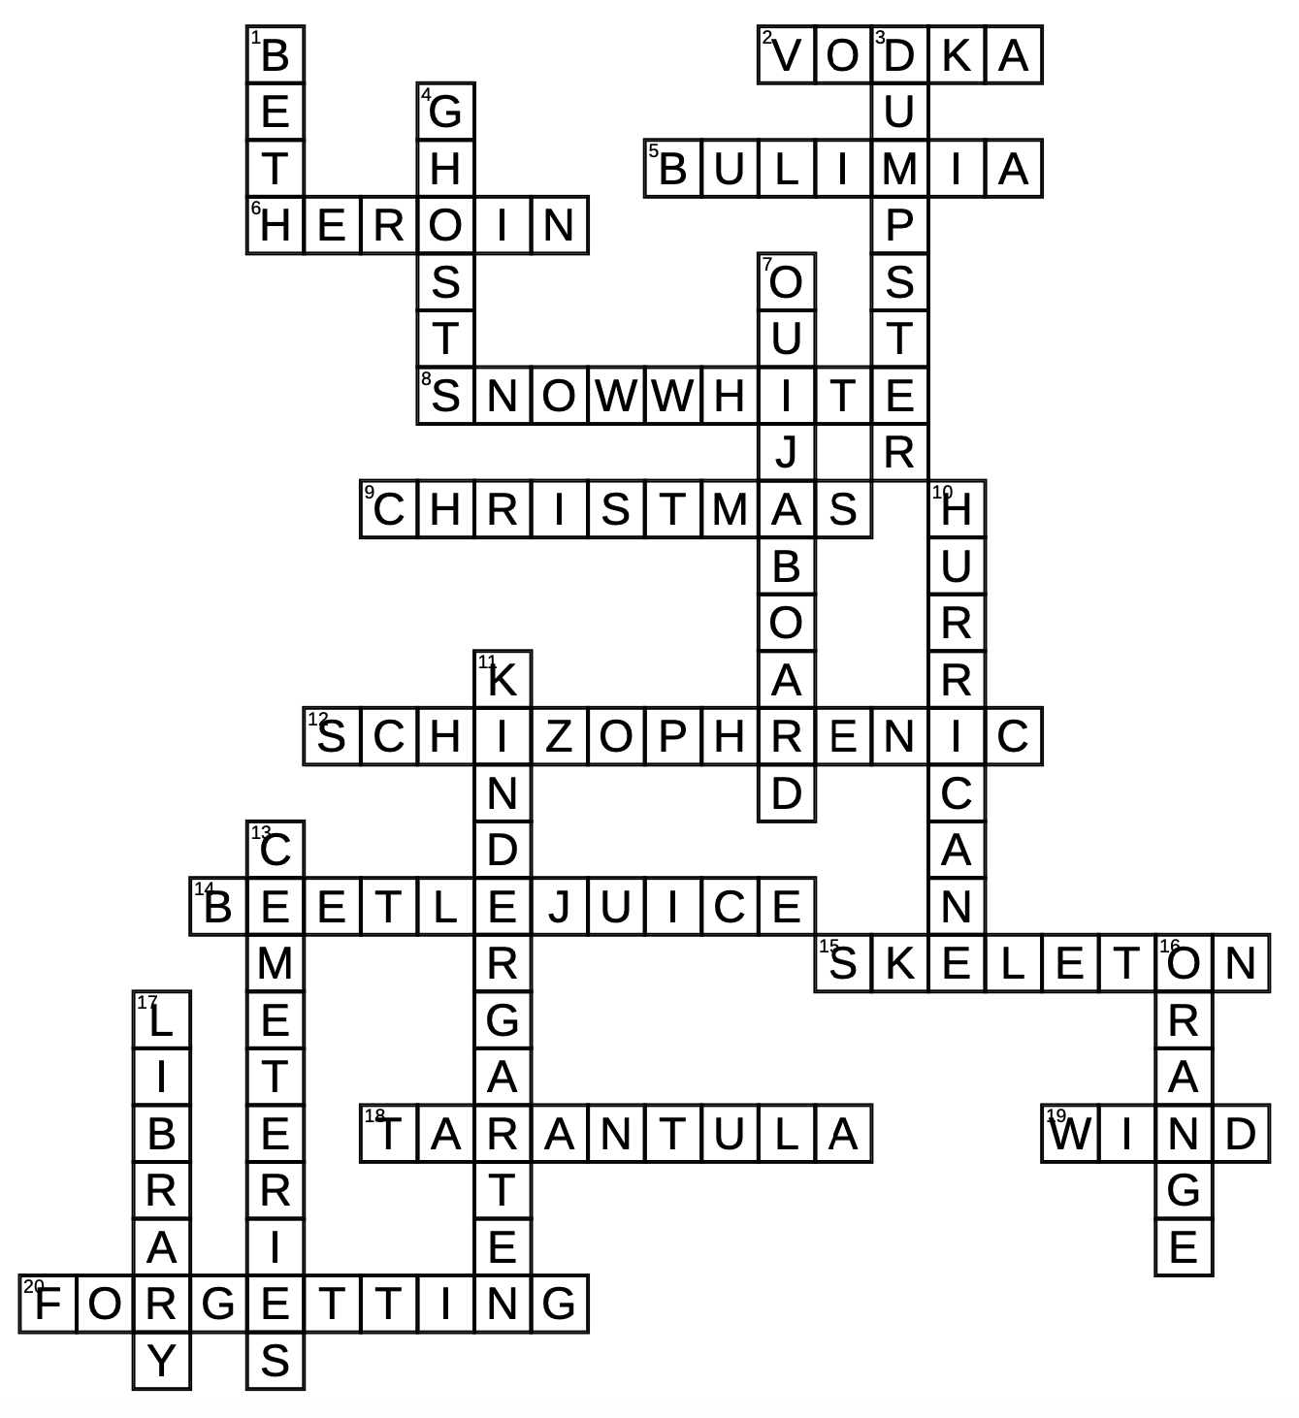

Down  1. I gave you a “best friends” necklace in seventh grade that you never wore in public because you were somehow ashamed of me.  3. The location where I chugged coconut rum straight from the bottle on my 18th birthday right before your band went on stage.  4. The reason I take anxiety medication is because I am a ghost scared of this.  7. The first time I felt like I might be able to have real school friends we were "playing" with this.  10. We slept in the same bed, our bodies always covered in sand, our feet making scratching noises against the cotton sheets. We had to be evacuated when this hit.  11. The place where the room erupted in sobs at the start of our first day and we all felt abandoned.  13. Where I bought LSD when I was 16. Where we made flower crowns for our hair. Where we got busted by the cops for running in the sprinklers. Where I ran to after my heart was broken the first time. Where we had the Victorian picnic on my birthday.  16. The night light in the upstairs hallway was lit with this color bulb.  17. When I stopped sleeping at night because I was convinced my house was not haunted but that instead, I was. We left early and walked four miles into the city to go here. | Across  2. The thing my mother gave me to help me stop crying when I was 15 and my emotions were like cats in a bag.  5. When my parents were mad at me for wasting money on food, when they should have been concerned, or scared, I had this.  6. What you told me you were addicted to because you thought it would make you seem more interesting, troubled, and romantic. I was a stupid 15-year-old and I believed you.  8. The former barn cat that licked my feet when I had a fever of 103.  9. l "ruined" this holiday because I wore jean shorts over thermal leggings and combat boots to dinner.  12. I knew if I could just make it past my twenties, the chance of me becoming like the rest of the women in my family would be much lower, and then maybe, just maybe, if I could breathe, I would know that I was not.  14. We were on the way to watch this movie the day you fell off your scooter and ripped your leg open, and Little Missy got bumped by a car in the parking lot. Bleeding, you both sat on the floor in the aisle scooping ice out of our sodas to get the swelling to go down.  15. The thing I feared for at least one full school year after Katherine Hennesy told me she saw this in her hallway.  18. When I came back from Belize I didn't unpack my backpack, it sat in a heap in the kitchen until my mother finally opened it. This was what she had found.  19. What made my father's hands shake with fear.  20. This game that I try so hard to play and so hard not to play, this game of…

